**SUMMER TRAINING REPORT**

**AT**

**Akatva TCS ION**

**ON**

**INTRODUCTION TO WEB TECHNOLOGY**

**JavaScript**



Submitted By

Name: **Tanya Gupta**

University Roll No. **03511502716**

Semester: **4th**

**SUBMITTED TO:**

**Department of Computer Science**

BHARATI VIDYAPEETh’s college OF engineering

NEW DELHI

**1**

**DECLARATION**

I hereby declare that the Summer Training Report entitled ("Let’s Play") is an authentic record of my own work as requirements of Summer Training during the period from 7th June 2018 to 21st July 2018 for stating the completion of Summer Training at Akatva TCS ION, Noida, under the guidance of (Mr. Piyush Gupta) and submitted to Bharati Vidyapeeth’s College of Engineering, New Delhi.

**(Signature of student)**

**Tanya Gupta**

**03511502716**

**Date: ____________________**

**2**

**ACKNOWLEDGEMENT**

To make any project, essential requirement is able guidance and references without which project is incomplete. I am very much thankful to **Mr. Piyush Gupta** who has provided us an opportunity and motivation to gain knowledge through this type of project. I will get practical knowledge from this project and this will help me a lot in my career.

I am also thankful to **Akatva TCS ION** for giving us the guidance of their faculty members, as they have provided me with valuable input resources and knowledge for preparing my project.

At last but not the least, I am thankful to all my colleagues, friends, my college faculty and other people who have directly or indirectly helped me during preparation of report.

**Thank You**

**Name:** Tanya Gupta

**Enrollment Number:** 03511502716

**Course:** B.Tech (CSE)

**Semester:** 4th

**College:** BVCOE

**University:** GGSIPU

**3**

**TABLE OF CONTENTS**

|  |  |  |
| --- | --- | --- |
| ***S. No.*** | ***Content*** | ***Page No.*** |
| 1. | Declaration | 2 |
| 2. | Acknowledgement | 3 |
| 3. | Introduction to JavaScript | 5-9 |
| 4. | AngularJS | 10-12 |
| 5. | Backbone JS | 13-15 |
| 6. | React JS | 15-16 |
| 7. | About Project and Result | 17-21 |
| 8. | Source Code | 21-54 |
| 9. | Conclusion | 55 |

**4**

1. **INTRODUCTION TO JAVASCRIPT**

**1.1 What is JavaScript?**

**JavaScript** often abbreviated as **JS**, is a high-level, interpreted programming language. It is a language which is also characterized as dynamic, weakly typed, prototype-based and multi-paradigm.

Alongside [HTML](https://en.wikipedia.org/wiki/HTML) and [CSS](https://en.wikipedia.org/wiki/CSS), JavaScript is one of the three core technologies of the [World Wide Web](https://en.wikipedia.org/wiki/World_Wide_Web). JavaScript enables interactive [web pages](https://en.wikipedia.org/wiki/Web_page) and thus is an essential part of [web applications](https://en.wikipedia.org/wiki/Web_application). The vast majority of [websites](https://en.wikipedia.org/wiki/Website) use it and all major [web browsers](https://en.wikipedia.org/wiki/Web_browser) have a dedicated [JavaScript engine](https://en.wikipedia.org/wiki/JavaScript_engine) to execute it.

As a multi-paradigm language, JavaScript supports [event-driven](https://en.wikipedia.org/wiki/Event-driven_programming), [functional](https://en.wikipedia.org/wiki/Functional_programming), and [imperative](https://en.wikipedia.org/wiki/Imperative_programming) (including [object-oriented](https://en.wikipedia.org/wiki/Object-oriented_programming) and [prototype-based](https://en.wikipedia.org/wiki/Prototype-based_programming)) [programming styles](https://en.wikipedia.org/wiki/Programming_paradigm). It has an [API](https://en.wikipedia.org/wiki/Application_programming_interface) for working with text, [arrays](https://en.wikipedia.org/wiki/Array_data_type), dates, [regular expressions](https://en.wikipedia.org/wiki/Regular_expression), and basic manipulation of the [DOM](https://en.wikipedia.org/wiki/Document_Object_Model), but the language itself does not include any [I/O](https://en.wikipedia.org/wiki/Input/output), such as networking, storage, or graphics facilities, relying for these upon the host environment in which it is embedded.

Initially only implemented [client-side](https://en.wikipedia.org/wiki/Client-side) in web browsers, JavaScript engines are now embedded in many other types of host software, including [server-side](https://en.wikipedia.org/wiki/Server-side) in web servers and databases, and in non-web programs such as word processors and [PDF](https://en.wikipedia.org/wiki/Portable_Document_Format) software, and in runtime environments that make JavaScript available for writing mobile and desktop applications, including desktop widgets.

Although there are strong outward similarities between JavaScript and [Java](https://en.wikipedia.org/wiki/Java_(programming_language)), including language name, [syntax](https://en.wikipedia.org/wiki/Syntax_(programming_languages)), and respective [standard libraries](https://en.wikipedia.org/wiki/Standard_library), the two languages are distinct and differ greatly in design; JavaScript was influenced by programming languages such as [Self](https://en.wikipedia.org/wiki/Self_(programming_language))and [Scheme](https://en.wikipedia.org/wiki/Scheme_(programming_language)).

* 1. **History**

**Beginnings At Netscape**

**5**

In 1995, Netscape Communications recruited Brendan Eich with the goal of embedding the Scheme programming language into its Netscape Navigator. Before he could get started, Netscape Communications collaborated with Sun Microsystems to include in Netscape Navigator Sun's more static programming language Java, in order to compete with Microsoft for user adoption of Web technologies and platforms. Netscape Communications then decided that the scripting language they wanted to create would complement Java and should have a similar syntax, which excluded adopting other languages such as Perl, Python, TCL, or Scheme. To defend the idea of JavaScript against competing proposals, the company needed a prototype. Eich wrote one in 10 days, in May 1995.

Although it was developed under the name **Mocha**, the language was officially called **LiveScript** when it first shipped in beta releases of Netscape Navigator 2.0 in September 1995, but it was renamed **JavaScript** when it was deployed in the Netscape Navigator 2.0 beta 3 in December. The final choice of name caused confusion, giving the impression that the language was a spin-off of the Java programming language, and the choice has been characterized as a marketing ploy by Netscape to give JavaScript the cachet of what was then the hot new Web programming language.

**Adoption by Microsoft**

Microsoft script technologies including [VBScript](https://en.wikipedia.org/wiki/VBScript) and [JScript](https://en.wikipedia.org/wiki/JScript) were released in 1996. JScript, a reverse-engineered implementation of Netscape's JavaScript, was part of [Internet Explorer 3](https://en.wikipedia.org/wiki/Internet_Explorer_3). JScript was also available for server-side scripting in [Internet Information Server](https://en.wikipedia.org/wiki/Internet_Information_Server). Internet Explorer 3 also included Microsoft's first support for CSS and various extensions to HTML, but in each case the implementation was noticeably different to that found in Netscape Navigator at the time. These differences made it difficult for designers and programmers to make a single website work well in both browsers, leading to the use of "best viewed in Netscape" and "best viewed in Internet Explorer" logos that characterized these early years of the [browser wars](https://en.wikipedia.org/wiki/Browser_wars). JavaScript began to acquire a reputation for being one of the roadblocks to a cross-platform and standards-driven Web. Some developers took on the difficult task of trying to make their sites work in both major browsers, but many could not afford the time. With the release

**6**

of Internet Explorer 4, Microsoft introduced the concept of Dynamic HTML, but the differences in language implementations and the different and proprietary Document Object Models remained and were obstacles to widespread take-up of JavaScript on the Web.

### Later developments

JavaScript has become one of the most popular programming languages on the Web. Initially, however, many professional programmers denigrated the language because, among other reasons, its target audience consisted of Web authors and other such "amateurs". The advent of Ajax returned JavaScript to the spotlight and brought more professional programming attention. The result was a proliferation of comprehensive frameworks and libraries, improved JavaScript programming practices, and increased usage of JavaScript outside Web browsers, as seen by the proliferation of Server-side JavaScript platforms.

In January 2009, the CommonJS project was founded with the goal of specifying a common standard library mainly for JavaScript development outside the browser.

With the rise of single-page applications and JavaScript-heavy sites, it is increasingly being used as a compile target for source-to-source compilers from both dynamic languages and static languages.

**1.3** [**What can in-browser JavaScript do?**](https://javascript.info/intro#what-can-in-browser-javascript-do)

The modern JavaScript is a “safe” programming language. It does not provide low-level access to memory or CPU, because it was initially created for browsers which do not require it.

The capabilities greatly depend on the environment that runs JavaScript. For instance, Node.JS supports functions that allow JavaScript to read/write arbitrary files, perform network requests etc.

In-browser JavaScript can do everything related to webpage manipulation, interaction with the user and the webserver.

**7**

For instance, in-browser JavaScript is able to:

* Add new HTML to the page, change the existing content, modify styles.
* React to user actions, run on mouse clicks, pointer movements, key presses.
* Send requests over the network to remote servers, download and upload files (so-called AJAX and COMET technologies).
* Get and set cookies, ask questions to the visitor, show messages.
* Remember the data on the client-side (“local storage”).

## **1.4** [**What CAN’T in-browser JavaScript do?**](https://javascript.info/intro#what-can-t-in-browser-javascript-do)

JavaScript’s abilities in the browser are limited for the sake of the user’s safety. The aim is to prevent an evil webpage from accessing private information or harming the user’s data.

The examples of such restrictions are:

* JavaScript on a webpage may not read/write arbitrary files on the hard disk, copy them or execute programs. It has no direct access to OS system functions.

Modern browsers allow it to work with files, but the access is limited and only provided if the user does certain actions, like “dropping” a file into a browser window or selecting it via an <input> tag.

There are ways to interact with camera/microphone and other devices, but they require a user’s explicit permission. So a JavaScript-enabled page may not sneakily enable a web-camera, observe the surroundings and send the information to the NSA.

* Different tabs/windows generally do not know about each other. Sometimes they do, for example when one window uses JavaScript to open the other one. But even in this case, JavaScript from one page may not access the other if they come from different sites (from a different domain, protocol or port).

This is called the “Same Origin Policy”. To work around that, both pages must contain a special JavaScript code that handles data exchange.

The limitation is again for user’s safety. A page from http://anysite.com which a user has opened must not be able to access another browser tab with the

**8**

URL http://gmail.com and steal information from there.

* JavaScript can easily communicate over the net to the server where the current page came from. But its ability to receive data from other sites/domains is crippled. Though possible, it requires explicit agreement (expressed in HTTP headers) from the remote side. Once again, that’s safety limitations.

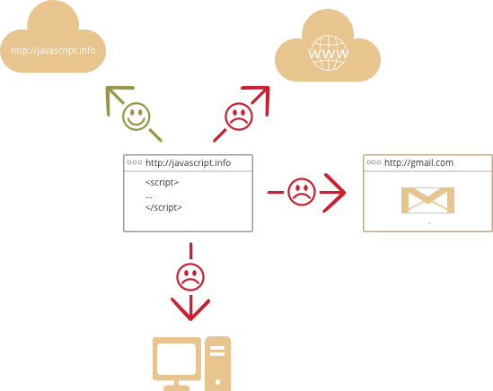

**9**

**2. ANGULAR JS**

**2.1 Introduction**

**AngularJS** (also written as **Angular.js**) is a JavaScript-based open-source front-end web application framework mainly maintained by Google and by a community of individuals and corporations to address many of the challenges encountered in developing single-page applications. The JavaScript components complement Apache Cordova, a framework used for developing cross-platform mobile apps. It aims to simplify both the development and the testing of such applications by providing a framework for client-side model–view–controller (MVC) and model–view–viewmodel (MVVM) architectures, along with components commonly used in rich Internet applications. In 2014, the original AngularJS team began working on the Angular application platform.

AngularJS is built on the belief that declarative programming should be used to create user interfaces and connect software components, while imperative programming is better suited to defining an application's business logic. The framework adapts and extends traditional HTML to present dynamic content through two-way data-binding that allows for the automatic synchronization of models and views. As a result, AngularJS de-emphasizes explicit DOM manipulation with the goal of improving testability and performance.

AngularJS's design goals include:

* to decouple DOM manipulation from application logic. The difficulty of this is dramatically affected by the way the code is structured.
* to decouple the client side of an application from the server side. This allows development work to progress in parallel, and allows for reuse of both sides.
* to provide structure for the journey of building an application: from designing the UI, through writing the business logic, to testing.

AngularJS implements the MVC pattern to separate presentation, data, and logic components. Using dependency injection, Angular brings traditionally server-side services, such as view-dependent controllers, to client-side web applications.

**10**

Consequently, much of the burden on the server can be reduced.

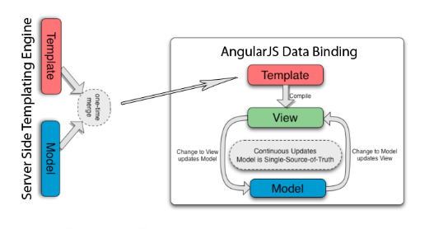

**2.2 History**

AngularJS was originally developed in 2009 by Miško Hevery at Brat Tech LLC as the software behind an online JSON storage service, that would have been priced by the megabyte, for easy-to-make applications for the enterprise. This venture was located at the web domain "GetAngular.com" and had a few subscribers, before the two decided to abandon the business idea and release Angular as an open-source library.

The 1.6 release added many of the concepts of Angular to AngularJS, including the concept of a component-based application architecture. This release among others removed the Sandbox, which many developers believed provided additional security, despite numerous vulnerabilities that had been discovered that bypassed the sandbox. The current (as of June 2018) stable release of AngularJS is 1.7.0

In January 2018, a schedule was announced for phasing-out AngularJS: after releasing 1.7.0, the active development on AngularJS will continue till June 30, 2018. Afterwards, 1.7 will be supported till  June 30, 2021 as long-term support.

**11**

**2.3 Scope**

AngularJS uses the term "scope" in a manner akin to the fundamentals of computer science.

Scope in computer science describes when in the program a particular binding is valid. The ECMA-262 specification defines scope as: a lexical environment in which a Function object is executed in client-side web scripts; akin to how scope is defined in lambda calculus.

As a part of the "MVC" architecture, the scope forms the "Model", and all variables defined in the scope can be accessed by the "View" as well as the "Controller". The scope behaves as a glue and binds the "View" and the "Controller".

In AngularJS, "scope" is a certain kind of object that itself can be in scope or out of scope in any given part of the program, following the usual rules of variable scope in JavaScript like any other object. When the term "scope" is used below, it refers to the Angular scope object and not the scope of a name binding.

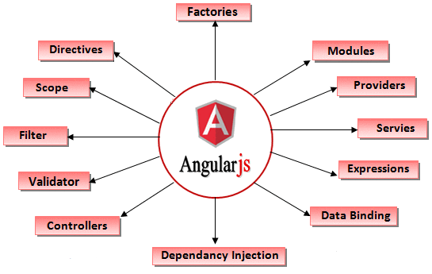

**12**

1. **BACKBONE.JS**
   1. **Introduction**

Backbone.js gives structure to web applications by providing models with key-value binding and custom events, collections with a rich API of enumerable functions, viewswith declarative event handling, and connects it all to your existing API over a RESTful JSON interface.

When working on a web application that involves a lot of JavaScript, one of the first things you learn is to stop tying your data to the DOM. It's all too easy to create JavaScript applications that end up as tangled piles of jQuery selectors and callbacks, all trying frantically to keep data in sync between the HTML UI, your JavaScript logic, and the database on your server. For rich client-side applications, a more structured approach is often helpful.

With Backbone, you represent your data as Models, which can be created, validated, destroyed, and saved to the server. Whenever a UI action causes an attribute of a model to change, the model triggers a "change" event; all the Views that display the model's state can be notified of the change, so that they are able to respond accordingly, re-rendering themselves with the new information. In a finished Backbone app, you don't have to write the glue code that looks into the DOM to find an element with a specific id, and update the HTML manually — when the model changes, the views simply update themselves.

Philosophically, Backbone is an attempt to discover the minimal set of data-structuring (models and collections) and user interface (views and URLs) primitives that are generally useful when building web applications with JavaScript. In an ecosystem where overarching, decides-everything-for-you frameworks are commonplace, and many libraries require your site to be reorganized to suit their look, feel, and default behavior — Backbone should continue to be a tool that gives you the freedom to design the full experience of your web application.

**13**

* 1. **Models and Views**

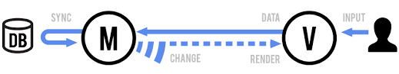

The single most important thing that Backbone can help you with is keeping your business logic separate from your user interface. When the two are entangled, change is hard; when logic doesn't depend on UI, your interface becomes easier to work with.

**Model**

* Orchestrates data and business logic.
* Loads and saves from the server.
* Emits events when data changes.

**View**

* Listens for changes and renders UI.
* Handles user input and interactivity.
* Sends captured input to the model.

A Model manages an internal table of data attributes, and triggers "change" events when any of its data is modified. Models handle syncing data with a persistence layer — usually a REST API with a backing database. Design your models as the atomic reusable objects containing all of the helpful functions for manipulating their particular bit of data. Models should be able to be passed around throughout your app, and used anywhere that bit of data is needed.

A View is an atomic chunk of user interface. It often renders the data from a specific model, or number of models — but views can also be data-less chunks of UI that stand alone. Models should be generally unaware of views. Instead, views listen to the model "change" events, and react or re-render themselves appropriately.

**14**

* 1. **Collections**

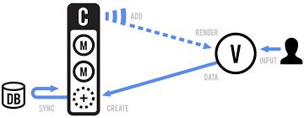

A Collection helps you deal with a group of related models, handling the loading and saving of new models to the server and providing helper functions for performing aggregations or computations against a list of models. Aside from their own events, collections also proxy through all of the events that occur to models within them, allowing you to listen in one place for any change that might happen to any model in the collection.

1. **REACT JS**

**4.1 Introduction**

In computing, **React** (also known as **React.js** or **ReactJS**) is a JavaScript library for building user interfaces. It is maintained by Facebook and a community of individual developers and companies.

React can be used as a base in the development of single-page or mobile applications. Complex React applications usually require the use of additional libraries for state management, routing, and interaction with an API.

**15**

**4.2 History**

React was created by Jordan Walke, a software engineer at Facebook. He was influenced by XHP, an HTML component framework for PHP. It was first deployed on Facebook's newsfeed in 2011 and later on Instagram.com in 2012. It was open-sourced at JSConf US in May 2013.

React Native, which enables native Android, iOS, and UWP development with React, was announced at Facebook's React.js Conf in February 2015 and open-sourced in March 2015.

On April 18, 2017, Facebook announced React Fiber, a new core algorithm of React framework library for building user interfaces. React Fiber was to become the foundation of any future improvements and feature development of the React framework.

**4.3 Future Development**

Project status can be tracked via the core team discussion forum. However, major changes to React go through the Future of React repository issues and pull requests. This enables the React community to provide feedback on new potential features, experimental APIs and JavaScript syntax improvements.

### Sub projects

The status of the React sub-projects used to be available in the project wiki.

### Facebook CLA

Facebook requires contributors to React to sign the Facebook CLA.

## **4.4 Criticism of ReactJS**

A criticism of ReactJS is that it has high memory (RAM) requirements, since it uses the concept of a "Virtual DOM". This is where "a representation of a UI is kept in memory and synced with the 'real' DOM by a library such as ReactDOM."

**16**

1. **ABOUT PROJECT AND RESULTS**

This project is a thorough study of JavaScript i.e. ECMA-5 and ECMA-6 and its framework AngularJS including its theoretical and practical aspects. This project is framed on Sublime as its text editor.

* 1. **Software and Tools used**

**Languages Used –** The whole project was done using **HTML, CSS and JavaScript**. HTML5, CSS3 was used as User Interface languages as they have more tags, elements and styling properties compared to their previous versions. Being the latest version up till when the project was completed both HTML5 and CSS3 has the most features available.

JavaScript has a wide scope in web technology as it can be used to make a UI interactive and responsive as well as it can be used as backend language (Node.js). It can be used to validate data at client side only so that the extra time spent while validating data at server side could be saved. JavaScript can handle various events i.e. mouse click events, key press events etc. It provides functions for handling events and it can dynamically manipulate as well as access various HTML tags.

**FrameWork Used – AngularJS** is a framework of JavaScript that uses ECMA5. AngularJS is used for making one page application so that the web page can run a bit faster as it does not require continuous reloading for moving from one functionality of a page to another. This is one of the reason that it was suitable for this project. It also provides few functional dependencies like for routing it use ng-route, for animation it use ng-animate.

**Text Editor Used –** This project is made on sublime text 3 text editor as it made the switching from one directory to another easy and hassle free. According to the extension of the file it auto completes various pre-defined keywords and also indents the whole code which is then easy to read and debug.

**17**

**HOMEPAGE**

This is the homepage of the project which includes two image links to tic-tac-toe and Tetris games.

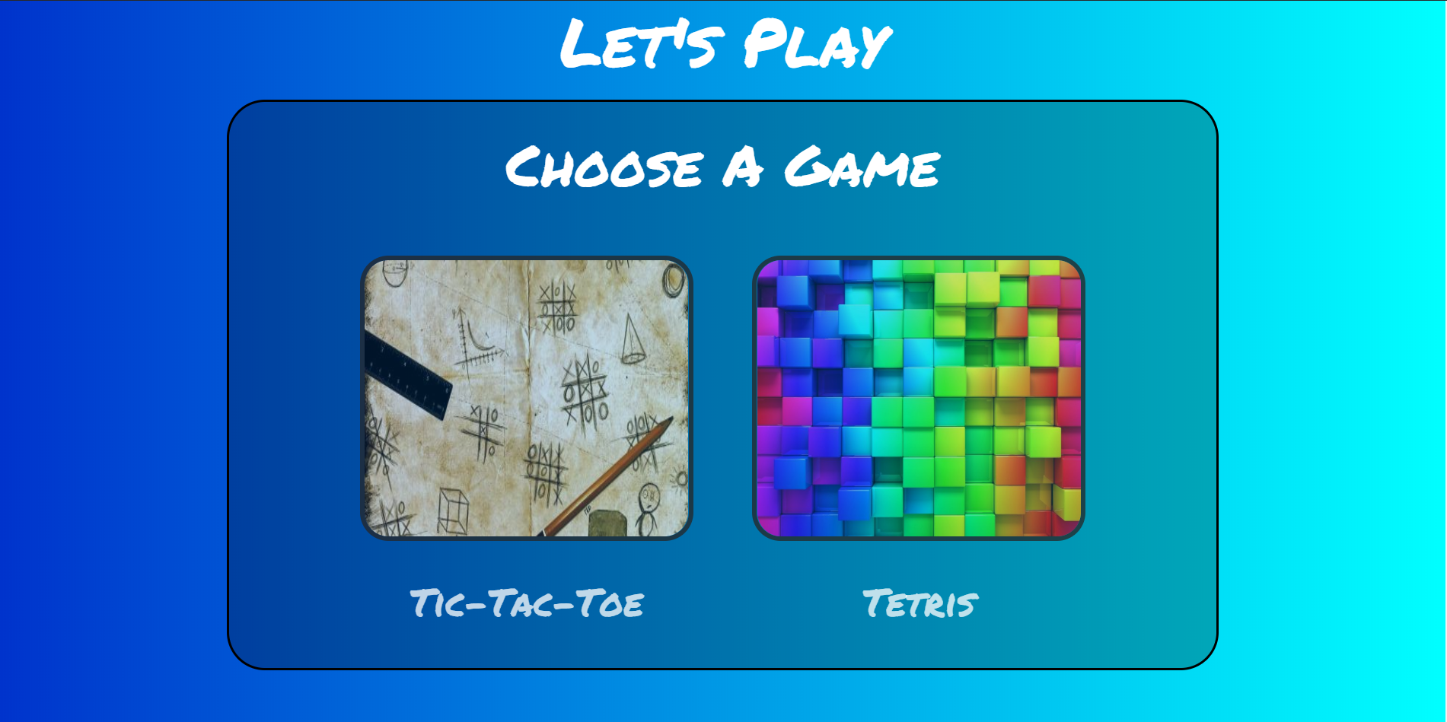

**TIC-TAC-TOE**

This is the tic-tac-toe front page which contains options for the game and a back button to go back to the project home page. The page contains two options one player and two player, and what the first player wants to use as playing symbol. This game is a one page application i.e. it does not need reloading for processing.

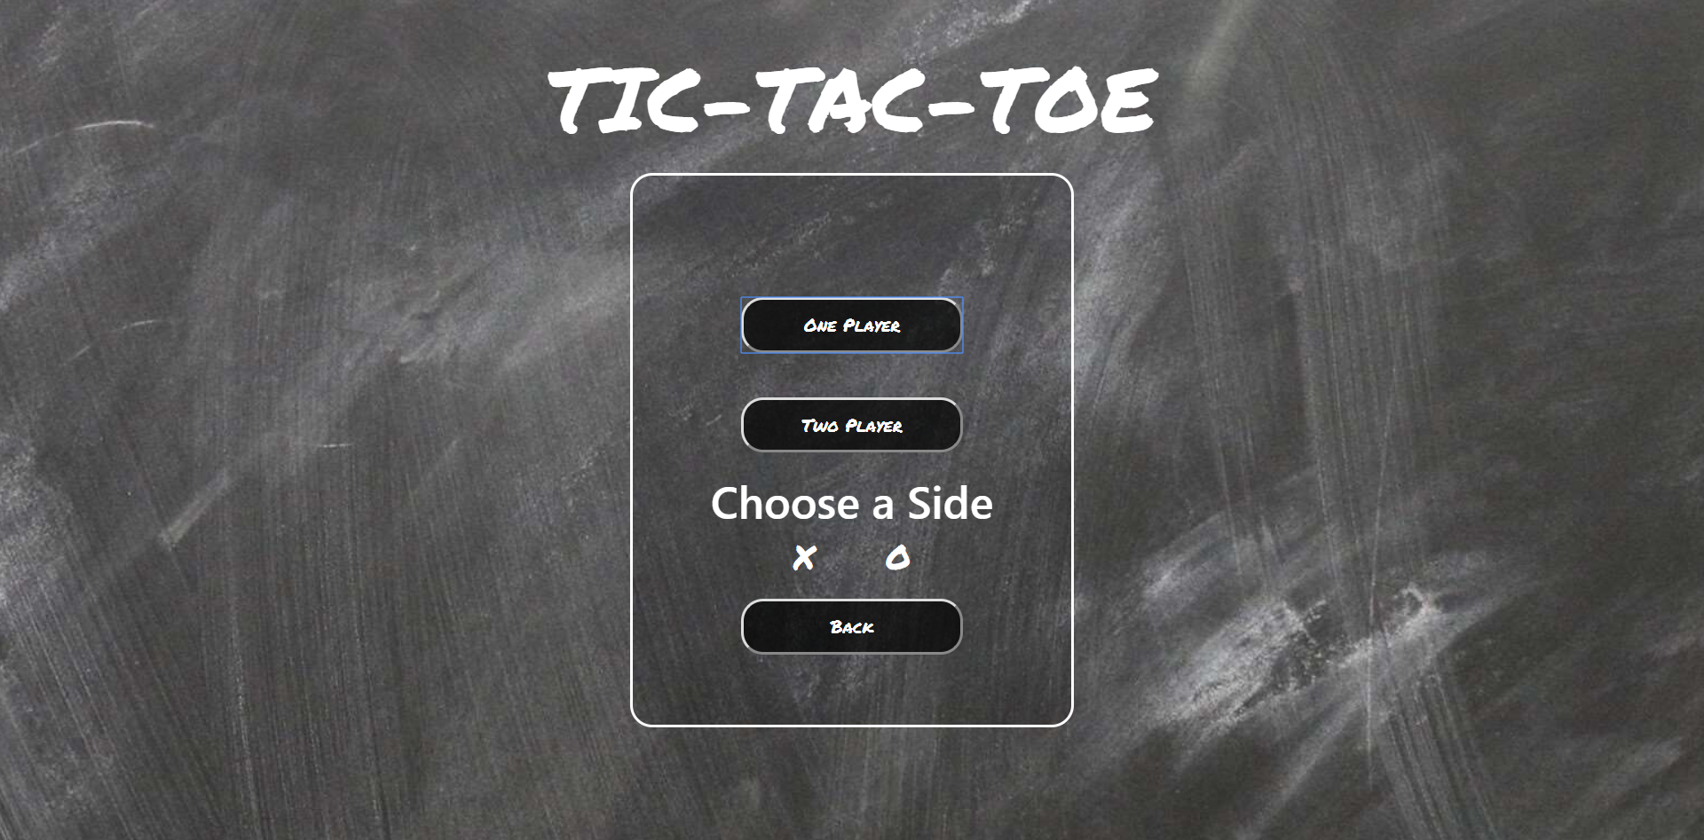

**18**

**ONE PLAYER PLAYING SCREEN**

This is the grid page containing the playing grid for one player, a reset button to reset the game with the win counter of the computer and the player. The back button on the screen takes the user back to the tic-tac-toe options page.

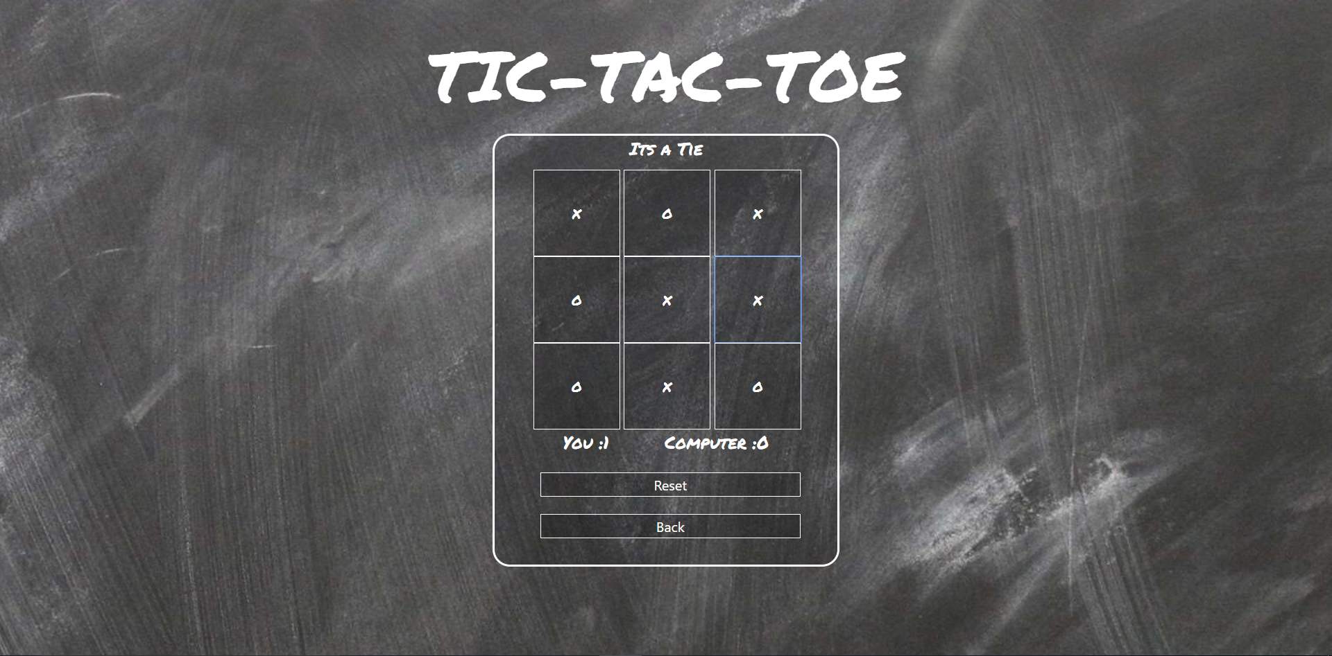

**TWO PLAYER PLAYING SCREEN**

This is the grid page containing the playing grade for two players, like the one player page the reset button resets the game, the player1 and player2 win counter and the back button to get the user back to the options page

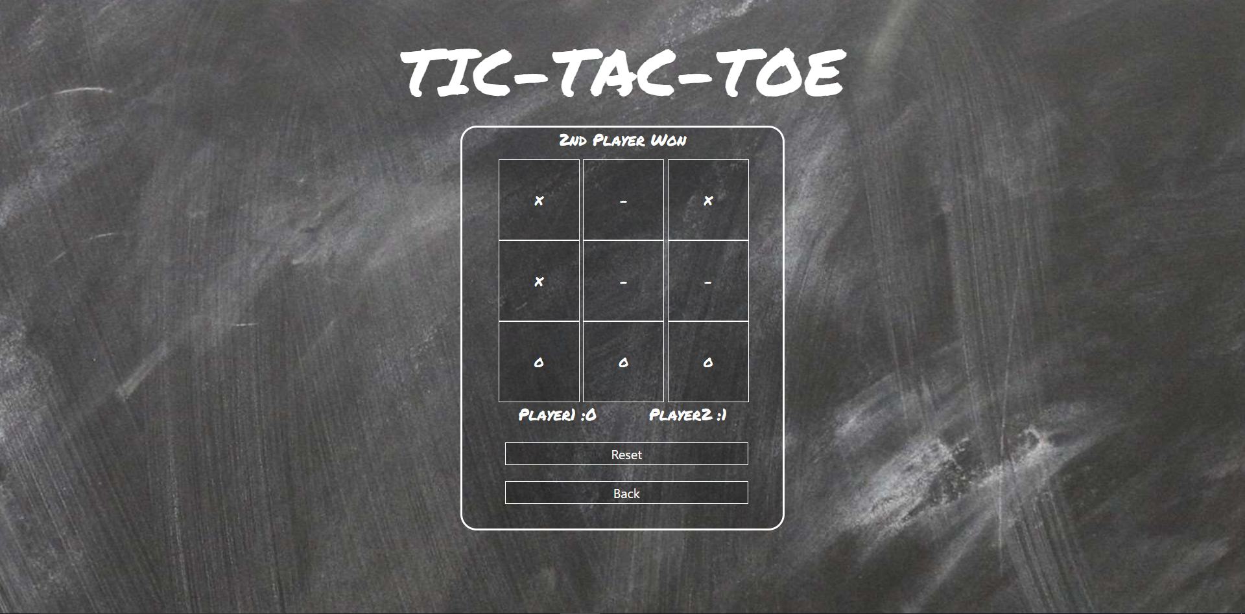

**19**

**TETRIS**

This is the tetris front page which is showing the modal with the option to start a new game. This game is made on ECMA-6.

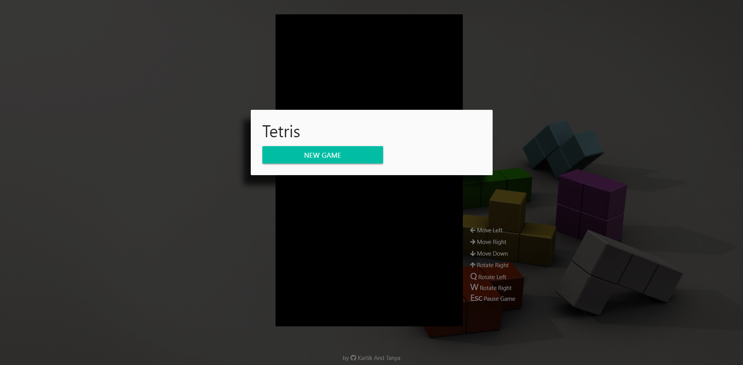

**GAME**

The middle canvas is the playing canvas, on the right it contains the instructions to play the game with the next coming shape. On the left it contains the score and level, with the increasing level the speed of the shapes coming down increases.

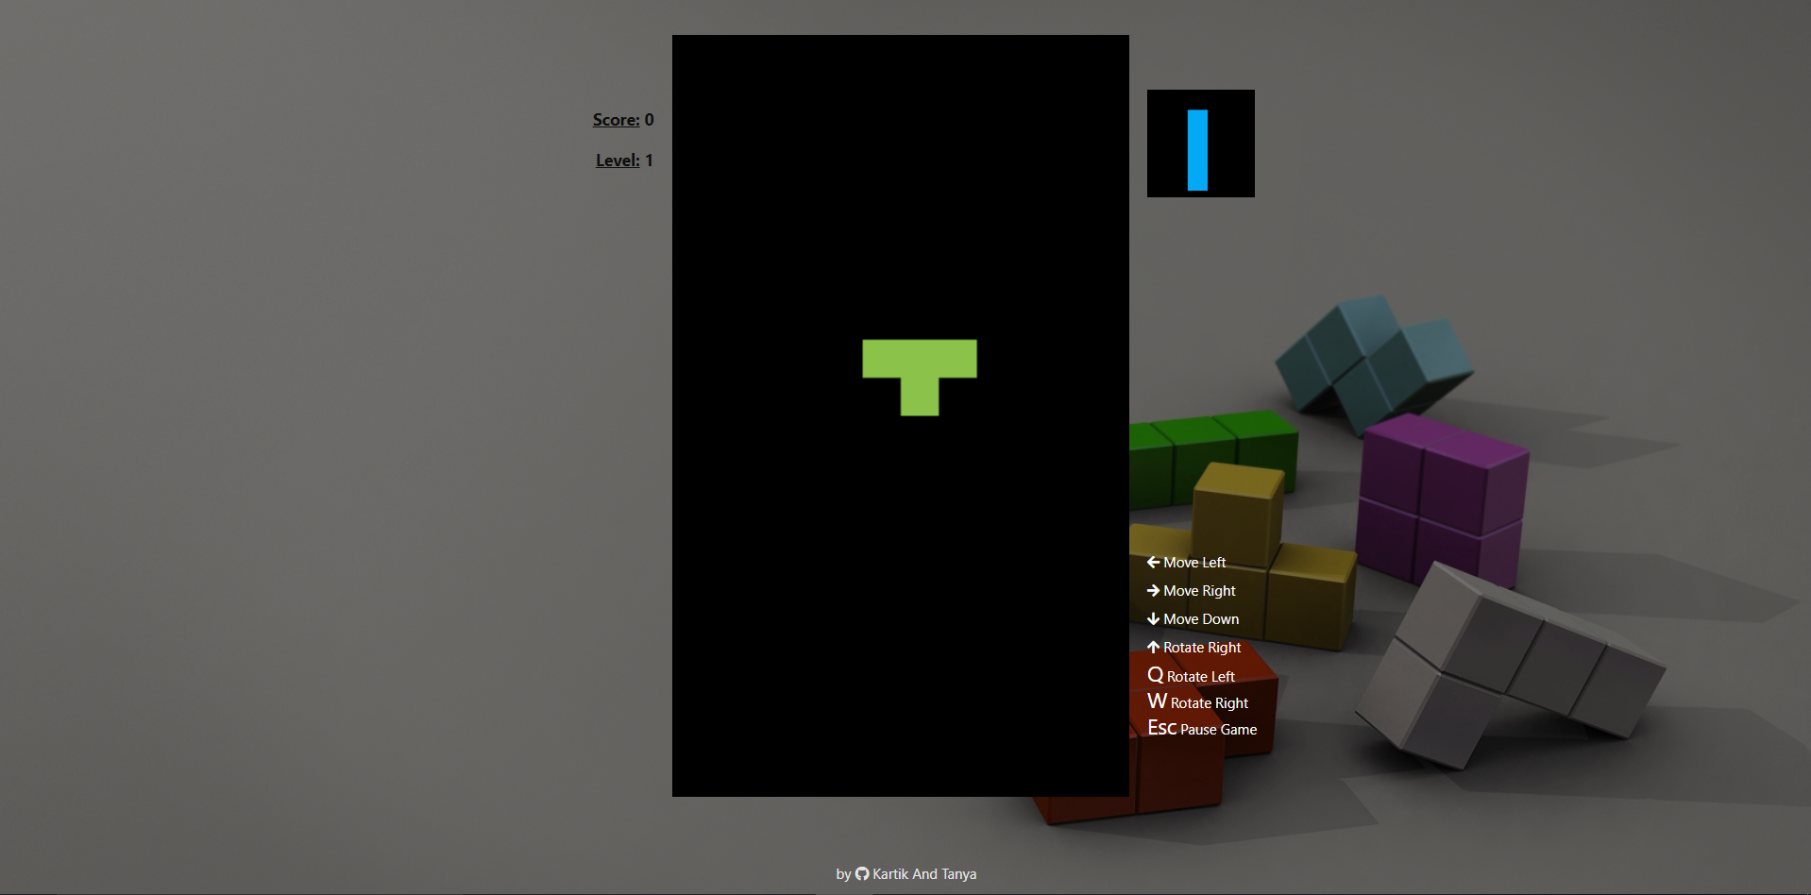

**20**

**GAME OVER**

The game over Modal shows the score and two options, the start new game option starts a new game and the exit options takes the user back to the project homepage.

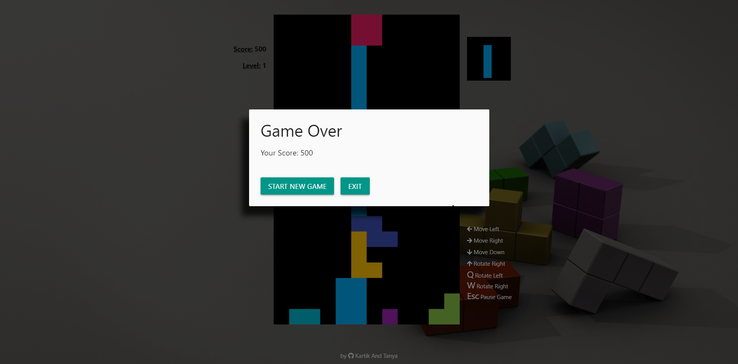

1. **SOURCE CODE**
   1. **HOME PAGE**
      1. **INDEX**

<!doctype html>

<html>

<head>

<link rel="stylesheet" href="https://maxcdn.bootstrapcdn.com/bootstrap/4.1.0/css/bootstrap.min.css">

<link href="https://fonts.googleapis.com/css?family=Permanent+Marker" rel="stylesheet">

<script src="angular.min.js"></script>

<script src="angular-route.js"></script>

<script src="angular-animate.js"></script>

<script src="module.js"></script>

<link href="style.css" rel="stylesheet">

<base href="/">

</head>

<body ng-app="myApp1">

<div class="container-fluid">

<div class="text-center">

<div class="home"></div>

</div>

</div>

</body>

</html>

**21**

* + 1. **HOME TEMPLATE**

<div class="Outer">

<h1 class="title">Choose A Game</h1>

<div class="tictactoe col-md-5">

<a href="Project/tic">

<img src="Project/ttt.jpg" class="image">

<h1 class="innertitle">Tic-Tac-Toe</h1>

</a>

</div>

<div class="tetris col-md-5">

<a href="Project/tetris">

<img src="Project/tetris.jpg" class="image">

<h1 class="innertitle">Tetris</h1>

</a>

</div>

</div>

* + 1. **MODULE**

var app1=angular.module('myApp1',['ngRoute','ngAnimate']);

app1.directive('home',function(){

return{

restrict:'C',

templateUrl:"Project/home.html"

}

})

* + 1. **STYLESHEET**

body{

background: linear-gradient(to right, #0033cc 0%, #00ffff 100%);

}

.title{

margin-bottom: 60px;

font-size:60px;

font-family: 'Permanent Marker', cursive;

color:white;

}

.innertitle{

margin-top: 40px;

font-family: 'Permanent Marker', cursive;

color:white;

text-decoration-color:white;

margin-bottom: 40px;

}

.innertitle:hover{

text-decoration:none;

cursor:pointer;

}

.text-center{

text-align: center;

}

.Outer{

height:650px;

width:70%;

border:2px solid black;

border-radius: 40px;

margin:60px auto;

background-color: rgba(0,0,0,0.25);

padding:30px;

}

**22**

.image{

height:300px;

width:350px;

border-radius: 30px;

border:5px solid #262525;

}

.image:hover{

box-shadow: 5px 5px 8px #262525;

}

.tictactoe{

display: inline-block;

opacity:0.75;

text-decoration:none;

}

.tetris{

display: inline-block;

opacity:0.75;

text-decoration:none;

}

.tictactoe:hover{

opacity:1;

cursor:pointer;

text-decoration:none;

}

.tetris:hover{

opacity:1;

cursor:pointer;

text-decoration:none;

}

@media (min-width:300px) and (max-width: 1360px)

{

.tictactoe{

margin:0px auto;

display: block;

opacity:0.75;

text-decoration:none;

text-align: center;

}

.tetris{

margin:0px auto;

display: block;

text-align: center;

opacity:0.75;

text-decoration:none;

}

.Outer{

height:1050px;

}

}

* 1. **TIC-TAC-TOE**
     1. **INDEX**

<!doctype html>

<html>

<head>

<link rel="stylesheet" href="https://maxcdn.bootstrapcdn.com/bootstrap/4.1.0/css/bootstrap.min.css">

<link href="https://fonts.googleapis.com/css?family=Permanent+Marker" rel="stylesheet">

<script src="angular.min.js"></script>

<script src="angular-route.js"></script>

<script src="angular-animate.js"></script>

**23**

<script src="module.js"></script>

<link href="styleind.css" rel="stylesheet">

<link href="style1.css" rel="stylesheet">

<base href="/">

</head>

<body ng-app="myApp" ng-controller="cntrl">

<div class="container-fluid">

<div class="text-center">

<h1 class = "title">TIC-TAC-TOE</h1>

<div class="outer text-center">

<ng-view></ng-view>

</div>

</div>

</div>

</body>

</html>

* + 1. **HOME TEMPLATE**

<div class="shift">

<button class="selection" ng-click="op()">One Player</button><br>

<button class="selection" ng-click="tp()">Two Player</button><br>

<h1 class="intitle" id="title">Choose a Side</h1>

<a href="X" ><h1 class="rad" id="xrad" ng-click="x()">X</h1></a>

<a href="O" ><h1 class="rad" id="orad" ng-click="o()">O</h1></a><br>

<a href="project"><button class="selection">Back</button></a>

</div>

* + 1. **GRID TEMPLATE**

<span class = "your-turn">{{pla}}</span>

<div class="game">

<div class="row color">

<div class="col-xs-4">

<button class="square" id="one" value="1" ng-click="A()">-</button>

<button class="square" id="two" value="2" ng-click="B()">-</button>

<button class="square" id="three" value="3" ng-click="C()">-</button>

</div>

</div>

<div class="row color">

<div class="col-xs-4">

<button class="square" id="four" value="4" ng-click="D()">-</button>

<button class="square" id="five" value="5" ng-click="E()">-</button>

<button class="square" id="six" value="6" ng-click="F()">-</button>

</div>

</div>

<div class="row color">

<div class="col-xs-4">

<button class="square" id="seven" value="7" ng-click="G()">-</button>

<button class="square" id="eight" value="8" ng-click="H()">-</button>

<button class="square" id="nine" value="9" ng-click="I()">-</button>

</div>

</div>

**24**

<p id = "computer-points">{{pla1}} :{{mark1}}</p>

<p id = "player-points">{{pla2}} :{{mark2}}</p><br>

<button class="back" ng-click="reset1()">Reset</button>

<a href="Project/tic"><button class="back" ng-click="reset()">Back</button></a>

</div>

* + 1. **MODULE**

var app=angular.module('myApp',['ngRoute']);

app.controller('cntrl',function($scope){

$scope.id="";

$scope.decide=[];

$scope.arr=[["1","2","3"],

["4","5","6"],

["7","8","9"]];

$scope.results=[["one","two","three"],

["four","five","six"],

["seven","eight","nine"]];

$scope.mark1=0;

$scope.mark2=0;

$scope.op=function(){

$scope.decide[0]="op";

title.style.display="block";

xrad.style.display="inline";

orad.style.display="inline";

$scope.pla1="You";

$scope.pla2="Computer";

$scope.pla="Let the Game Begin !!!";

}

$scope.tp=function(){

$scope.decide[0]="tp";

title.style.display="block";

xrad.style.display="inline";

orad.style.display="inline";

$scope.pla1="Player1";

$scope.pla2="Player2";

$scope.pla="1st Player";

}

$scope.x=function(){

$scope.decide[1]="x";

}

$scope.o=function(){

$scope.decide[1]="o";

}

$scope.result=0;

$scope.counter=0;

$scope.check=function(){

$scope.a=document.getElementById('one').value;

$scope.b=document.getElementById('two').value;

$scope.c=document.getElementById('three').value;

$scope.d=document.getElementById('four').value;

$scope.e=document.getElementById('five').value;

$scope.f=document.getElementById('six').value;

$scope.g=document.getElementById('seven').value;

$scope.h=document.getElementById('eight').value;

$scope.i=document.getElementById('nine').value;

if(($scope.a==$scope.b && $scope.b==$scope.c && $scope.counter>=4 )||($scope.d==$scope.e && $scope.e==$scope.f && $scope.counter>=4 )||($scope.g==$scope.h && $scope.h==$scope.i && $scope.counter>=4

**25**

)||($scope.a==$scope.e && $scope.e==$scope.i && $scope.counter>=4 )||($scope.g==$scope.e && $scope.e==$scope.c && $scope.counter>=4 )||($scope.a==$scope.d && $scope.d==$scope.g &&

$scope.counter>=4 ) || ($scope.b==$scope.e && $scope.e==$scope.h && $scope.counter>=4 ) || ($scope.c==$scope.f && $scope.f==$scope.i && $scope.counter>=4)){

$scope.result=1;

document.getElementById('one').disabled=true;

document.getElementById('two').disabled=true;

document.getElementById('three').disabled=true;

document.getElementById('four').disabled=true;

document.getElementById('five').disabled=true;

document.getElementById('six').disabled=true;

document.getElementById('seven').disabled=true;

document.getElementById('eight').disabled=true;

document.getElementById('nine').disabled=true;

}

else{

$scope.result=0;

}

}

$scope.moves = function(var1,var2){

$scope.copy=[];

for(i = 0 ; i<3 ; i++){

$scope.copy.push([]);

for(j = 0;j<3;j++){

$scope.copy[i][j] = $scope.arr[i][j];

}

}

console.log($scope.copy);

if($scope.copy[0][0]==$scope.copy[0][2] && $scope.arr[0][1]=="2"){

$scope.id=$scope.results[0][1];

$scope.arr[0][1]=var1

}

else if($scope.copy[1][0]==$scope.copy[1][2] && $scope.arr[1][1]=="5"){

$scope.id=$scope.results[1][1];

$scope.arr[1][1]=var1

}

else if($scope.copy[2][0]==$scope.copy[2][2] && $scope.arr[2][1]=="8"){

$scope.id=$scope.results[2][1];

$scope.arr[2][1]=var1

}

else if($scope.copy[0][0]==$scope.copy[0][1] && $scope.arr[0][2]=="3"){

$scope.id=$scope.results[0][2];

$scope.arr[0][2]=var1

}

else if($scope.copy[0][1]==$scope.copy[0][2] && $scope.arr[0][0]=="1"){

$scope.id=$scope.results[0][0];

$scope.arr[0][0]=var1

}

else if($scope.copy[1][0]==$scope.copy[1][1] && $scope.arr[1][2]=="6"){

$scope.id=$scope.results[1][2];

$scope.arr[1][2]=var1

}

else if($scope.copy[1][1]==$scope.copy[1][2] && $scope.arr[1][0]=="4"){

**26**

$scope.id=$scope.results[1][0];

$scope.arr[1][0]=var1

}

else if($scope.copy[2][0]==$scope.copy[2][1] && $scope.arr[2][2]=="9"){

$scope.id=$scope.results[2][2];

$scope.arr[2][2]=var1

}

else if($scope.copy[2][1]==$scope.copy[2][2] && $scope.arr[2][0]=="7"){

$scope.id=$scope.results[2][0];

$scope.arr[2][0]=var1

}

else if($scope.copy[0][0]==$scope.copy[2][0] && $scope.arr[1][0]=="4"){

$scope.id=$scope.results[1][0];

$scope.arr[1][0]=var1

}

else if($scope.copy[0][1]==$scope.copy[2][1] && $scope.arr[1][1]=="5"){

$scope.id=$scope.results[1][1];

$scope.arr[1][1]=var1

}

else if($scope.copy[0][2]==$scope.copy[2][2] && $scope.arr[1][2]=="6"){

$scope.id=$scope.results[1][2];

$scope.arr[1][2]=var1

}

else if($scope.copy[0][0]==$scope.copy[1][0] && $scope.arr[2][0]=="7"){

$scope.id=$scope.results[2][0];

$scope.arr[2][0]=var1

}

else if($scope.copy[1][0]==$scope.copy[2][0] && $scope.arr[0][0]=="1"){

$scope.id=$scope.results[0][0];

$scope.arr[0][0]=var1

}

else if($scope.copy[0][1]==$scope.copy[1][1] && $scope.arr[2][1]=="8"){

$scope.id=$scope.results[2][1];

$scope.arr[2][1]=var1

}

else if($scope.copy[1][1]==$scope.copy[2][1] && $scope.arr[0][1]=="2"){

$scope.id=$scope.results[0][1];

$scope.arr[0][1]=var1

}

else if($scope.copy[0][2]==$scope.copy[1][2] && $scope.arr[2][2]=="9"){

$scope.id=$scope.results[2][2];

$scope.arr[2][2]=var1

}

else if($scope.copy[1][2]==$scope.copy[2][2] && $scope.arr[0][2]=="3"){

$scope.id=$scope.results[0][2];

$scope.arr[0][2]=var1

}

else if($scope.copy[0][0]==$scope.copy[2][2] && $scope.arr[1][1]=="5"){

$scope.id=$scope.results[1][1];

$scope.arr[1][1]=var1

}

else if($scope.copy[0][0]==$scope.copy[1][1] && $scope.arr[2][2]=="9"){

**27**

$scope.id=$scope.results[2][2];

$scope.arr[2][2]=var1

}

else if($scope.copy[1][1]==$scope.copy[2][2] && $scope.arr[0][0]=="1"){

$scope.id=$scope.results[0][0];

$scope.arr[0][0]=var1

}

else if($scope.copy[2][0]==$scope.copy[0][2] &&

$scope.arr[1][1]=="5"){

$scope.id=$scope.results[1][1];

$scope.arr[1][1]=var1

}

else if($scope.copy[2][0]==$scope.copy[1][1] && $scope.arr[0][2]=="3"){

$scope.id=$scope.results[0][2];

$scope.arr[0][2]=var1

}

else if($scope.copy[1][1]==$scope.copy[0][2] && $scope.arr[2][0]=="7"){

$scope.id=$scope.results[2][0];

$scope.arr[2][0]=var1

}

else{

if($scope.copy[0][0]!=="X" && $scope.copy[0][0]!=="O"){

$scope.id=$scope.results[0][0];

$scope.arr[0][0]=var1

}

else if($scope.copy[2][0]!=="X" && $scope.copy[2][0]!=="O"){

$scope.id=$scope.results[2][0];

$scope.arr[2][0]=var1

}

else if($scope.copy[0][2]!=="X" && $scope.copy[0][2]!=="O"){

$scope.id=$scope.results[0][2];

$scope.arr[0][2]=var1

}

else if($scope.copy[2][2]!=="X" && $scope.copy[2][2]!=="O"){

$scope.id=$scope.results[2][2];

$scope.arr[2][2]=var1

}

else if($scope.copy[1][1]=="5" ){

$scope.id=$scope.results[1][1];

$scope.arr[1][1]=var1

}

else if($scope.copy[0][1]=="2" ){

$scope.id=$scope.results[0][1];

$scope.arr[0][1]=var1

}

else if($scope.copy[1][0]=="4" ){

$scope.id=$scope.results[1][0];

$scope.arr[1][0]=var1

}

else if($scope.copy[1][2]=="6" ){

$scope.id=$scope.results[1][2];

$scope.arr[1][2]=var1

}

else if($scope.copy[2][1]=="8" ){

$scope.id=$scope.results[2][1];

$scope.arr[2][1]=var1

}

}

}

**28**

$scope.reset=function(){

document.getElementById('one').value="1";

document.getElementById('two').value="2";

document.getElementById('three').value="3";

document.getElementById('four').value="4";

document.getElementById('five').value="5";

document.getElementById('six').value="6";

document.getElementById('seven').value="7";

document.getElementById('eight').value="8";

document.getElementById('nine').value="9";

document.getElementById('one').innerHTML="-";

document.getElementById('two').innerHTML="-";

document.getElementById('three').innerHTML="-";

document.getElementById('four').innerHTML="-";

document.getElementById('five').innerHTML="-";

document.getElementById('six').innerHTML="-";

document.getElementById('seven').innerHTML="-";

document.getElementById('eight').innerHTML="-";

document.getElementById('nine').innerHTML="-";

document.getElementById('one').disabled=false;

document.getElementById('two').disabled=false;

document.getElementById('three').disabled=false;

document.getElementById('four').disabled=false;

document.getElementById('five').disabled=false;

document.getElementById('six').disabled=false;

document.getElementById('seven').disabled=false;

document.getElementById('eight').disabled=false;

document.getElementById('nine').disabled=false;

$scope.result=0;

$scope.counter=0;

$scope.turn=1;

$scope.pla="1st Player";

$scope.mark1=0;

$scope.mark2=0;

$scope.arr=[["1","2","3"],

["4","5","6"],

["7","8","9"]];

}

$scope.reset1=function(){

document.getElementById('one').value="1";

document.getElementById('two').value="2";

document.getElementById('three').value="3";

document.getElementById('four').value="4";

document.getElementById('five').value="5";

document.getElementById('six').value="6";

document.getElementById('seven').value="7";

document.getElementById('eight').value="8";

document.getElementById('nine').value="9";

document.getElementById('one').innerHTML="-";

document.getElementById('two').innerHTML="-";

document.getElementById('three').innerHTML="-";

**29**

document.getElementById('four').innerHTML="-";

document.getElementById('five').innerHTML="-";

document.getElementById('six').innerHTML="-";

document.getElementById('seven').innerHTML="-";

document.getElementById('eight').innerHTML="-";

document.getElementById('nine').innerHTML="-";

document.getElementById('one').disabled=false;

document.getElementById('two').disabled=false;

document.getElementById('three').disabled=false;

document.getElementById('four').disabled=false;

document.getElementById('five').disabled=false;

document.getElementById('six').disabled=false;

document.getElementById('seven').disabled=false;

document.getElementById('eight').disabled=false;

document.getElementById('nine').disabled=false;

$scope.result=0;

$scope.counter=0;

$scope.turn=1;

$scope.pla="1st Player";

$scope.arr=[["1","2","3"],

["4","5","6"],

["7","8","9"]];

}

$scope.turn=1;

$scope.A=function(){

if($scope.decide[0]=="tp"){

if($scope.decide[1]=="x"){

$scope.p="X";

$scope.s="O";

}else{

$scope.p="O";

$scope.s="X";

}

$scope.counter+=1;

if($scope.turn==1){

document.getElementById('one').value=$scope.p;

document.getElementById('one').innerHTML=$scope.p;

$scope.pla="2nd Player";

$scope.turn=2;

}

else if($scope.turn==2){

document.getElementById('one').value=$scope.s;

document.getElementById('one').innerHTML=$scope.s;

$scope.pla="1st Player";

$scope.turn=1;

}

$scope.check();

if($scope.result==1){

if($scope.turn==1){

$scope.pla="2nd Player Won";

$scope.mark2+=1;

}

else if($scope.turn==2){

$scope.pla="1st Player won";

$scope.mark1+=1;

}

}

else if($scope.result==0 && $scope.counter>=9){

$scope.pla="Its a Tie";

**30**

}

document.getElementById('one').disabled=true;

}

else if($scope.decide[0]=="op"){

if($scope.decide[1]=="x"){

$scope.p="X";

$scope.s="O";

}else{

$scope.p="O";

$scope.s="X";

}

$scope.counter+=2;

document.getElementById('one').value=$scope.p;

document.getElementById('one').innerHTML=$scope.p;

// $scope.pla="AI's Turn";

$scope.turn=2;

$scope.check();

if($scope.result==1){

if($scope.turn==2){

$scope.pla="You won";

$scope.mark1+=1;

return 0;

}

}

$scope.arr[0][0]=$scope.p;

console.log($scope.id);

console.log($scope.results[0][0]);

$scope.moves($scope.s,$scope.p);

document.getElementById($scope.id).value = $scope.s;

document.getElementById($scope.id).innerHTML = $scope.s;

document.getElementById($scope.id).disabled = true;

$scope.turn=1;

//$scope.pla="Your Turn";

$scope.check();

if($scope.result==1){

if($scope.turn==1){

$scope.pla="AI Won";

$scope.mark2+=1;

}

}

else if($scope.result==0 && $scope.counter>=9){

$scope.pla="Its a Tie";

return 0;

}

document.getElementById('one').disabled=true;

}

}

$scope.B=function(){

if($scope.decide[0]=="tp"){

if($scope.decide[1]=="x"){

$scope.p="X";

$scope.s="O";

}else{

$scope.p="O";

$scope.s="X";

}

$scope.counter+=1;

if($scope.turn==1){

document.getElementById('two').value=$scope.p;

document.getElementById('two').innerHTML=$scope.p;

**31**

$scope.pla="2nd Player";

$scope.turn=2;

}

else if($scope.turn==2){

document.getElementById('two').value=$scope.s;

document.getElementById('two').innerHTML=$scope.s;

$scope.pla="1st Player";

$scope.turn=1;

}

$scope.check();

if($scope.result==1){

if($scope.turn==1){

$scope.pla="2nd Player Won";

$scope.mark2+=1;

}

else if($scope.turn==2){

$scope.pla="1st Player won";

$scope.mark1+=1;

}

}

else if($scope.result==0 && $scope.counter>=9){

$scope.pla="Its a Tie";

}

document.getElementById('two').disabled=true;

}

else if($scope.decide[0]=="op"){

if($scope.decide[1]=="x"){

$scope.p="X";

$scope.s="O";

}else{

$scope.p="O";

$scope.s="X";

}

$scope.counter+=2;

document.getElementById('two').value=$scope.p;

document.getElementById('two').innerHTML=$scope.p;

//$scope.pla="AI's Turn";

$scope.turn=2;

$scope.check();

if($scope.result==1){

if($scope.turn==2){

$scope.pla="You won";

$scope.mark1+=1;

return 0;

}

}

$scope.arr[0][1]=$scope.p;

$scope.moves($scope.s,$scope.p);

document.getElementById($scope.id).value = $scope.s;

document.getElementById($scope.id).innerHTML = $scope.s;

document.getElementById($scope.id).disabled = true;

$scope.turn=1;

//$scope.pla="Your Turn";

$scope.check();

if($scope.result==1){

if($scope.turn==1){

**32**

$scope.pla="AI Won";

$scope.mark2+=1;

}

}

else if($scope.result==0 && $scope.counter>=9){

$scope.pla="Its a Tie";

return 0;

}

document.getElementById('two').disabled=true;

}

}

$scope.C=function(){

if($scope.decide[0]=="tp"){

if($scope.decide[1]=="x"){

$scope.p="X";

$scope.s="O";

}else{

$scope.p="O";

$scope.s="X";

}

$scope.counter+=1;

if($scope.turn==1){

document.getElementById('three').value=$scope.p;

document.getElementById('three').innerHTML=$scope.p;

$scope.pla="2nd Player";

$scope.turn=2;

}

else if($scope.turn==2){

document.getElementById('three').value=$scope.s;

document.getElementById('three').innerHTML=$scope.s;

$scope.pla="1st Player";

$scope.turn=1;

}

$scope.check();

if($scope.result==1){

if($scope.turn==1){

$scope.pla="2nd Player Won";

$scope.mark2+=1;

}

else if($scope.turn==2){

$scope.pla="1st Player won";

$scope.mark1+=1;

}

}

else if($scope.result==0 && $scope.counter>=9){

$scope.pla="Its a Tie";

}

document.getElementById('three').disabled=true;

}

else if($scope.decide[0]=="op"){

if($scope.decide[1]=="x"){

$scope.p="X";

$scope.s="O";

}else{

$scope.p="O";

$scope.s="X";

}

$scope.counter+=2;

**33**

document.getElementById('three').value=$scope.p;

document.getElementById('three').innerHTML=$scope.p;

//$scope.pla="AI's Turn";

$scope.turn=2;

$scope.check();

if($scope.result==1){

if($scope.turn==2){

$scope.pla="You won";

$scope.mark1+=1;

return 0;

}

}

$scope.arr[0][2]=$scope.p;

$scope.moves($scope.s,$scope.p);

document.getElementById($scope.id).value = $scope.s;

document.getElementById($scope.id).innerHTML = $scope.s;

document.getElementById($scope.id).disabled = true;

$scope.turn=1;

//$scope.pla="Your Turn";

$scope.check();

if($scope.result==1){

if($scope.turn==1){

$scope.pla="AI Won";

$scope.mark2+=1;

}

}

else if($scope.result==0 && $scope.counter>=9){

$scope.pla="Its a Tie";

return 0;

}

document.getElementById('three').disabled=true;

}

}

$scope.D=function(){

if($scope.decide[0]=="tp"){

if($scope.decide[1]=="x"){

$scope.p="X";

$scope.s="O";

}else{

$scope.p="O";

$scope.s="X";

}

$scope.counter+=1;

if($scope.turn==1){

document.getElementById('four').value=$scope.p;

document.getElementById('four').innerHTML=$scope.p;

$scope.pla="2nd Player";

$scope.turn=2;

}

else if($scope.turn==2){

document.getElementById('four').value=$scope.s;

document.getElementById('four').innerHTML=$scope.s;

$scope.pla="1st Player";

$scope.turn=1;

}

$scope.check();

if($scope.result==1){

if($scope.turn==1){

**34**

$scope.pla="2nd Player Won";

$scope.mark2+=1;

}

else if($scope.turn==2){

$scope.pla="1st Player won";

$scope.mark1+=1;

}

}

else if($scope.result==0 && $scope.counter>=9){

$scope.pla="Its a Tie";

}

document.getElementById('four').disabled=true;

}

else if($scope.decide[0]=="op"){

if($scope.decide[1]=="x"){

$scope.p="X";

$scope.s="O";

}else{

$scope.p="O";

$scope.s="X";

}

$scope.counter+=2;

document.getElementById('four').value=$scope.p;

document.getElementById('four').innerHTML=$scope.p;

//$scope.pla="AI's Turn";

$scope.turn=2;

$scope.check();

if($scope.result==1){

if($scope.turn==2){

$scope.pla="You won";

$scope.mark1+=1;

return 0;

}

}

$scope.arr[1][0]=$scope.p;

$scope.moves($scope.s,$scope.p);

document.getElementById($scope.id).value = $scope.s;

document.getElementById($scope.id).innerHTML = $scope.s;

document.getElementById($scope.id).disabled = true;

$scope.turn=1;

//$scope.pla="Your Turn";

$scope.check();

if($scope.result==1){

if($scope.turn==1){

$scope.pla="AI Won";

$scope.mark2+=1;

}

}

else if($scope.result==0 && $scope.counter>=9){

$scope.pla="Its a Tie";

return 0;

}

document.getElementById('four').disabled=true;

}

}

$scope.E=function(){

**35**

if($scope.decide[0]=="tp"){

if($scope.decide[1]=="x"){

$scope.p="X";

$scope.s="O";

}else{

$scope.p="O";

$scope.s="X";

}

$scope.counter+=1;

if($scope.turn==1){

document.getElementById('five').value=$scope.p;

document.getElementById('five').innerHTML=$scope.p;

$scope.pla="2nd Player";

$scope.turn=2;

}

else if($scope.turn==2){

document.getElementById('five').value=$scope.s;

document.getElementById('five').innerHTML=$scope.s;

$scope.pla="1st Player";

$scope.turn=1;

}

$scope.check();

if($scope.result==1){

if($scope.turn==1){

$scope.pla="2nd Player Won";

$scope.mark2+=1;

}

else if($scope.turn==2){

$scope.pla="1st Player won";

$scope.mark1+=1;

}

}

else if($scope.result==0 && $scope.counter>=9){

$scope.pla="Its a Tie";

}

document.getElementById('five').disabled=true;

}

else if($scope.decide[0]=="op"){

if($scope.decide[1]=="x"){

$scope.p="X";

$scope.s="O";

}else{

$scope.p="O";

$scope.s="X";

}

$scope.counter+=2;

document.getElementById('five').value=$scope.p;

document.getElementById('five').innerHTML=$scope.p;

//$scope.pla="AI's Turn";

$scope.turn=2;

$scope.check();

if($scope.result==1){

if($scope.turn==2){

$scope.pla="You won";

$scope.mark1+=1;

return 0;

}

**36**

}

$scope.arr[1][1]=$scope.p;

$scope.moves($scope.s,$scope.p);

document.getElementById($scope.id).value = $scope.s;

document.getElementById($scope.id).innerHTML = $scope.s;

document.getElementById($scope.id).disabled = true;

$scope.turn=1;

//$scope.pla="Your Turn";

$scope.check();

if($scope.result==1){

if($scope.turn==1){

$scope.pla="AI Won";

$scope.mark2+=1;

}

}

else if($scope.result==0 && $scope.counter>=9){

$scope.pla="Its a Tie";

return 0;

}

document.getElementById('five').disabled=true;

}

}

$scope.F=function(){

if($scope.decide[0]=="tp"){

if($scope.decide[1]=="x"){

$scope.p="X";

$scope.s="O";

}else{

$scope.p="O";

$scope.s="X";

}

$scope.counter+=1;

if($scope.turn==1){

document.getElementById('six').value=$scope.p;

document.getElementById('six').innerHTML=$scope.p;

$scope.pla="2nd Player";

$scope.turn=2;

}

else if($scope.turn==2){

document.getElementById('six').value=$scope.s;

document.getElementById('six').innerHTML=$scope.s;

$scope.pla="1st Player";

$scope.turn=1;

}

$scope.check();

if($scope.result==1){

if($scope.turn==1){

$scope.pla="2nd Player Won";

$scope.mark2+=1;

}

else if($scope.turn==2){

$scope.pla="1st Player won";

$scope.mark1+=1;

}

}

else if($scope.result==0 && $scope.counter>=9){

$scope.pla="Its a Tie";

}

document.getElementById('six').disabled=true;

**37**

}

else if($scope.decide[0]=="op"){

if($scope.decide[1]=="x"){

$scope.p="X";

$scope.s="O";

}else{

$scope.p="O";

$scope.s="X";

}

$scope.counter+=2;

document.getElementById('six').value=$scope.p;

document.getElementById('six').innerHTML=$scope.p;

//$scope.pla="AI's Turn";

$scope.turn=2;

$scope.check();

if($scope.result==1){

if($scope.turn==2){

$scope.pla="You won";

$scope.mark1+=1;

return 0;

}

}

$scope.arr[1][2]=$scope.p;

$scope.moves($scope.s,$scope.p);

document.getElementById($scope.id).value = $scope.s;

document.getElementById($scope.id).innerHTML = $scope.s;

document.getElementById($scope.id).disabled = true;

$scope.turn=1;

//$scope.pla="Your Turn";

$scope.check();

if($scope.result==1){

if($scope.turn==1){

$scope.pla="AI Won";

$scope.mark2+=1;

}

}

else if($scope.result==0 && $scope.counter>=9){

$scope.pla="Its a Tie";

return 0;

}

document.getElementById('six').disabled=true;

}

}

$scope.G=function(){

if($scope.decide[0]=="tp"){

if($scope.decide[1]=="x"){

$scope.p="X";

$scope.s="O";

}else{

$scope.p="O";

$scope.s="X";

}

$scope.counter+=1;

if($scope.turn==1){

document.getElementById('seven').value=$scope.p;

document.getElementById('seven').innerHTML=$scope.p;

$scope.pla="2nd Player";

$scope.turn=2;

}

**38**

else if($scope.turn==2){

document.getElementById('seven').value=$scope.s;

document.getElementById('seven').innerHTML=$scope.s;

$scope.pla="1st Player";

$scope.turn=1;

}

$scope.check();

if($scope.result==1){

if($scope.turn==1){

$scope.pla="2nd Player Won";

$scope.mark2+=1;

}

else if($scope.turn==2){

$scope.pla="1st Player won";

$scope.mark1+=1;

}

}

else if($scope.result==0 && $scope.counter>=9){

$scope.pla="Its a Tie";

}

document.getElementById('seven').disabled=true;

}

else if($scope.decide[0]=="op"){

if($scope.decide[1]=="x"){

$scope.p="X";

$scope.s="O";

}else{

$scope.p="O";

$scope.s="X";

}

$scope.counter+=2;

document.getElementById('seven').value=$scope.p;

document.getElementById('seven').innerHTML=$scope.p;

//$scope.pla="AI's Turn";

$scope.turn=2;

$scope.check();

if($scope.result==1){

if($scope.turn==2){

$scope.pla="You won";

$scope.mark1+=1;

return 0;

}

}

$scope.arr[2][0]=$scope.p;

$scope.moves($scope.s,$scope.p);

document.getElementById($scope.id).value = $scope.s;

document.getElementById($scope.id).innerHTML = $scope.s;

document.getElementById($scope.id).disabled = true;

$scope.turn=1;

//$scope.pla="Your Turn";

$scope.check();

if($scope.result==1){

if($scope.turn==1){

$scope.pla="AI Won";

$scope.mark2+=1;

}

}

**39**

else if($scope.result==0 && $scope.counter>=9){

$scope.pla="Its a Tie";

return 0;

}

document.getElementById('seven').disabled=true;

}

}

$scope.H=function(){

if($scope.decide[0]=="tp"){

if($scope.decide[1]=="x"){

$scope.p="X";

$scope.s="O";

}else{

$scope.p="O";

$scope.s="X";

}

$scope.counter+=1;

if($scope.turn==1){

document.getElementById('eight').value=$scope.p;

document.getElementById('eight').innerHTML=$scope.p;

$scope.pla="2nd Player";

$scope.turn=2;

}

else if($scope.turn==2){

document.getElementById('eight').value=$scope.s;

document.getElementById('eight').innerHTML=$scope.s;

$scope.pla="1st Player";

$scope.turn=1;

}

$scope.check();

if($scope.result==1){

if($scope.turn==1){

$scope.pla="2nd Player Won";

$scope.mark2+=1;

}

else if($scope.turn==2){

$scope.pla="1st Player won";

$scope.mark1+=1;

}

}

else if($scope.result==0 && $scope.counter>=9){

$scope.pla="Its a Tie";

}

document.getElementById('eight').disabled=true;

}

else if($scope.decide[0]=="op"){

if($scope.decide[1]=="x"){

$scope.p="X";

$scope.s="O";

}else{

$scope.p="O";

$scope.s="X";

}

$scope.counter+=2;

document.getElementById('eight').value=$scope.p;

document.getElementById('eight').innerHTML=$scope.p;

//$scope.pla="AI's Turn";

**40**

$scope.turn=2;

$scope.check();

if($scope.result==1){

if($scope.turn==2){

$scope.pla="You won";

$scope.mark1+=1;

return 0;

}

}

$scope.arr[2][1]=$scope.p;

$scope.moves($scope.s,$scope.p);

document.getElementById($scope.id).value = $scope.s;

document.getElementById($scope.id).innerHTML = $scope.s;

document.getElementById($scope.id).disabled = true;

$scope.turn=1;

//$scope.pla="Your Turn";

$scope.check();

if($scope.result==1){

if($scope.turn==1){

$scope.pla="AI Won";

$scope.mark2+=1;

}

}

else if($scope.result==0 && $scope.counter>=9){

$scope.pla="Its a Tie";

return 0;

}

document.getElementById('eight').disabled=true;

}

}

$scope.I=function(){

if($scope.decide[0]=="tp"){

if($scope.decide[1]=="x"){

$scope.p="X";

$scope.s="O";

}else{

$scope.p="O";

$scope.s="X";

}

$scope.counter+=1;

if($scope.turn==1){

document.getElementById('nine').value=$scope.p;

document.getElementById('nine').innerHTML=$scope.p;

$scope.pla="2nd Player";

$scope.turn=2;

}

else if($scope.turn==2){

document.getElementById('nine').value=$scope.s;

document.getElementById('nine').innerHTML=$scope.s;

$scope.pla="1st Player";

$scope.turn=1;

}

$scope.check();

if($scope.result==1){

if($scope.turn==1){

$scope.pla="2nd Player Won";

$scope.mark2+=1;

}

else if($scope.turn==2){

$scope.pla="1st Player won";

$scope.mark1+=1;

**41**

}

}

else if($scope.result==0 && $scope.counter>=9){

$scope.pla="Its a Tie";

}

document.getElementById('nine').disabled=true;

}

else if($scope.decide[0]=="op"){

if($scope.decide[1]=="x"){

$scope.p="X";

$scope.s="O";

}else{

$scope.p="O";

$scope.s="X";

}

$scope.counter+=2;

document.getElementById('nine').value=$scope.p;

document.getElementById('nine').innerHTML=$scope.p;

//$scope.pla="AI's Turn";

$scope.turn=2;

$scope.check();

if($scope.result==1){

if($scope.turn==2){

$scope.pla="You won";

$scope.mark1+=1;

return 0;

}

}

$scope.arr[2][2]=$scope.p;

$scope.moves($scope.s,$scope.p);

document.getElementById($scope.id).value = $scope.s;

document.getElementById($scope.id).innerHTML = $scope.s;

document.getElementById($scope.id).disabled = true;

$scope.turn=1;

//$scope.pla="Your Turn";

$scope.check();

if($scope.result==1){

if($scope.turn==1){

$scope.pla="AI Won";

$scope.mark2+=1;

}

}

else if($scope.result==0 && $scope.counter>=9){

$scope.pla="Its a Tie";

return 0;

}

document.getElementById('nine').disabled=true;

}

}

})

app.config(function($routeProvider,$locationProvider){

$routeProvider.when('/X',{

templateUrl:"Project/tic/grid.html"

}).when('/O',{

templateUrl:"Project/tic/grid.html"

}).when('/Project/tic',{

templateUrl:"Project/tic/home.html"

}).otherwise({

redirectTo: function(){

**42**

window.location.href = "http://localhost/project/";

}

})

$locationProvider.html5Mode(true); //For removing

$locationProvider.hashPrefix('!'); //#! from the url (Pretty url)

})

* + 1. **STYLESHEET**

.your-turn{

color:white;

margin-bottom:-20px;

font-family: 'Permanent Marker', cursive;

font-size: 20px;

transition:5s;

}

.game{

margin-left:60px;

margin-top:10px;

}

.square{

border:1px solid white;

height:100px;

width:100px;

background-color:rgba(0,0,0,0.2);

cursor:pointer;

font-family:'Permanent Marker', cursive;

color:white;

}

body{

background:url("http://www.tokkoro.com/picsup/3015158-blackboard_board_chalk_concept_empty_school_slate_smeared_writing-board.jpg") no-repeat center center;

}

p{

color:white;

display: inline;

margin-right:60px;

font-family: 'Permanent Marker', cursive;

font-size: 20px;

}

.back{

margin-top:20px;

width:300px;

margin-left:-50px;

border:1px solid white;

background-color: rgba(0,0,0,0.2);

color:white;

cursor:pointer;

}

.title{

font-family: 'Permanent Marker', cursive;

font-size:80px;

padding-top: 40px;

color:white;

}

.intitle{

color:white;

display:none;

}

.outer{

width:400px;

height:500px;

border:2px solid white;

**43**

border-radius: 20px;

margin:20px auto;

background-color:rgba(0,0,0,0.2);

}

.selection{

width:200px;

border-radius: 20px;

margin:20px auto;

font-family: 'Permanent Marker', cursive;

height:50px;

color:white;

background-color: rgba(0,0,0,0.7)

}

.shift{

margin-top:90px;

}

.rad{

margin:0px 30px 0px 30px;

font-family: 'Permanent Marker', cursive;

color:white;

font-size: 30px;

display:none;

}

.hide{

display:none;

}

body{

background:url("http://www.tokkoro.com/picsup/3015158-blackboard_board_chalk_concept_empty_school_slate_smeared_writing-board.jpg") no-repeat center center;

}

* 1. **TETRIS**
     1. **INDEX**

<html lang="en">

<head>

<meta charset="UTF-8">

<meta name="viewport" content="width=device-width, initial-scale=1.0">

<meta http-equiv="X-UA-Compatible" content="ie=edge">

<title>Tetris</title>

<link rel="stylesheet" href="tetris.css">

<link rel="stylesheet" href="https://cdnjs.cloudflare.com/ajax/libs/materialize/1.0.0-rc.2/css/materialize.min.css">

<link rel="stylesheet" href="https://use.fontawesome.com/releases/v5.1.0/css/all.css" integrity="sha384-lKuwvrZot6UHsBSfcMvOkWwlCMgc0TaWr+30HWe3a4ltaBwTZhyTEggF5tJv8tbt" crossorigin="anonymous">

</head>

<body style="background-image: url('http://cdn.miscellaneoushi.com/1680x1050/20121019/tetris%203d%20render%201680x1050%20wallpaper_www.miscellaneoushi.com_73.jpg');

background-size: cover;

background-repeat: no-repeat;

background-position: center;">

<div class="wrapper">

<div id="newGame" class="modal">

<div class="modal-content">

<h4>Tetris</h4>

<button onclick="newGame()" id="newGameBtn" class="modal-close

**44**

waves-effect waves-light btn" style="width:250px">New Game</button>

</div>

</div>

<div id="pause" class="modal">

<div class="modal-content">

<h4>Game Paused</h4>

<button onclick="pauseGame()" id="pauseBtn" class="modal-close waves-effect waves-light btn">Resume Game</button>

<button onclick="newGame()" id="StartNewBtn" class="modal-close waves-effect waves-light btn">Start New Game</button>

</div>

</div>

<div id="gameOver" class="modal">

<div class="modal-content">

<h4>Game Over</h4>

<div class="yourScore"></div>

<br>

<a onclick="newGame()" class="modal-close waves-effect waves-light btn">Start New Game</a>

&nbsp;

<a href="/Project" class="modal-close waves-effect waves-light btn">Exit</a>

</div>

</div>

<div class="detailsLeft">

<div class="score"></div>

<div class="level"></div>

<div class="highScores"></div>

</div>

<canvas class="tetris" width="240" height="400"></canvas>

<div class="detailsRight">

<canvas class="next" width="160" height="160"></canvas>

<br>

<div class="controls">

<p style="color:white"><span><i class="fas fa-arrow-left"></i></span> Move Left</p>

<p style="color:white"><span><i class="fas fa-arrow-right"></i></span> Move Right</p>

<p style="color:white"><span><i class="fas fa-arrow-down"></i></span> Move Down</p>

<p style="color:white"><i class="fas fa-arrow-up"></i></span> Rotate Right</p>

<p style="color:white"><span style="font-size : 18px">Q</span> Rotate Left</p>

<p style="color:white"><span style="font-size : 18px">W</span> Rotate Right</p>

<p style="color:white"><span style="font-size: 18px">Esc</span> Pause Game</p>

</div>

</div>

<div class="footer"><p>by <i class="fab fa-github"></i> Kartik And Tanya</p></div>

</div>

<script src="https://code.jquery.com/jquery-3.3.1.min.js" integrity="sha256-FgpCb/KJQlLNfOu91ta32o/NMZxltwRo8QtmkMRdAu8=" crossorigin="anonymous"></script>

<script src="https://cdnjs.cloudflare.com/ajax/libs/materialize/1.0.0-rc.2/js/materialize.min.js"></script>

<script src="tetris.js"></script>

**45**

</body>

</html>

* + 1. **JAVASCRIPT**

$(document).ready(function(){

$('#newGame').modal(

{'dismissible': false});

$('#newGame').modal('open');

$("#newGameBtn").focus()

});

let pause = true;

const canvas = document.querySelector('.tetris');

const context = canvas.getContext('2d');

const nextCanvas = document.querySelector('.next');

const nextContext = nextCanvas.getContext('2d');

context.scale(20, 20);

nextContext.scale(30, 30);

const arena = createMatrix(12, 20);

const nextArena = createMatrix(6, 6);

const player = {

pos: {x: 0, y: 0},

matrix: null,

score: 0,

level: 1,

dropInterval: 1000,

DROP_SLOW: 100,

next: null,

};

let dropCounter = 0;

let DROP_FAST = 50;

function arenaSweep(){

let rowCount = 1;

outer: for(y=arena.length - 1; y > 0; y--){

for(x=0; x < arena[y].length; x++){

if(arena[y][x] === 0) {

continue outer;

}

}

const row = arena.splice(y, 1)[0].fill(0);

arena.unshift(row);

y++;

player.score += rowCount * 100;

rowCount *= 2;

let scoreStr = player.score.toString();

if(scoreStr.length > 3){

let num = Number(scoreStr.slice(0, scoreStr.length - 3));

player.level = num + 1;

player.dropInterval = 1000 - (num * 50);

player.DROP_SLOW = 1000 - (num * 50);

}

}

}

**46**

function collide(arena, player){

const [m, o] = [player.matrix, player.pos];

for(y=0; y<m.length; y++){

for(x=0; x < m[y].length; x++){

if(m[y][x] !== 0 && ( arena[y + o.y] && arena[y + o.y][x + o.x]) !== 0){

return true;

}

}

}

return false;

}

function createMatrix(w, h){

const matrix = [];

while(h--){

matrix.push(new Array(w).fill(0));

}

return matrix;

}

function createPiece(type){

if (type === 'I'){

return [

[0, 1, 0, 0],

[0, 1, 0, 0],

[0, 1, 0, 0],

[0, 1, 0, 0]

];

} else if (type === 'J'){

return [

[0, 2, 0],

[0, 2, 0],

[2, 2, 0]

];

} else if (type === 'L'){

return [

[0, 3, 0],

[0, 3, 0],

[0, 3, 3]

];

} else if (type === 'O'){

return [

[4,4],

[4,4]

];

} else if (type === 'S'){

return [

[0, 5, 5],

[5, 5, 0],

[0, 0, 0]

];

} else if (type === 'T'){

return [

[0, 0, 0],

[6, 6, 6],

[0, 6, 0]

];

} else if (type === 'Z'){

return [

[7, 7, 0],

[0, 7, 7],

[0, 0, 0]

];

**47**

}

}

function drawNext(){

nextContext.fillStyle = '#000';

nextContext.fillRect(0, 0, nextCanvas.width, nextCanvas.height);

drawMatrix(nextArena, {x: 0, y:0}, nextContext);

drawMatrix(player.next, {x: 1, y: 1}, nextContext);

}

function draw(){

context.fillStyle = '#000';

context.fillRect(0, 0, canvas.width, canvas.height);

drawMatrix(arena, {x: 0, y: 0}, context);

drawMatrix(player.matrix, player.pos, context);

}

function drawMatrix(mat, offset, cont){

mat.forEach((row, y) => {

row.forEach((value, x) =>{

if(value !== 0){

cont.fillStyle = colors[value];

cont.fillRect(x + offset.x, y + offset.y, 1, 1);

}

});

});

}

function merge(arena, player){

player.matrix.forEach((row, y) => {

row.forEach((value, x) => {

if(value !== 0){

arena[y + player.pos.y][x + player.pos.x] = value;

}

});

});

}

function playerDrop(){

player.pos.y++;

if(collide(arena, player)){

player.pos.y--;

merge(arena, player);

playerReset();

arenaSweep();

updateScore();

}

dropCounter = 0;

}

function playerMove(dir){

player.pos.x += dir;

if(collide(arena, player)){

player.pos.x -= dir;

}

}

function playerReset(){

const pieces = 'IJLOSTZ';

if(player.next === null){

player.matrix = createPiece(pieces[pieces.length * Math.random() | 0]);

player.next = createPiece(pieces[pieces.length * Math.random() | 0]);

} else {

**48**

player.matrix = player.next;

player.next = createPiece(pieces[pieces.length * Math.random() | 0]);

}

drawNext();

player.pos.y = 0;

player.pos.x = (arena[0].length / 2 | 0) - (player.matrix[0].length / 2 | 0);

if(collide(arena, player)){

pauseGame();

document.removeEventListener('keydown', keyListener);

document.removeEventListener('keyup', keyListener);

// clearPlayer();

}

}

function clearPlayer(){

player.dropInterval = 1000;

player.DROP_SLOW = 1000;

player.score = 0;

player.level = 1;

arena.forEach(row => row.fill(0));

updateScore();

}

function playerRotate(dir){

const pos = player.pos.x

let offset = 1;

rotate(player.matrix, dir);

while(collide(arena, player)){

player.pos.x += offset;

offset = -(offset + (offset > 0 ? 1 : -1));

if(offset > player.matrix[0].length) {

rotate(player.matrix, -dir);

player.pos.x = pos;

return;

}

}

}

function rotate(matrix, dir){

for(y=0; y < matrix.length; y++){

for(x=0; x < y; x++){

[ matrix[x][y], matrix[y][x], ] = [ matrix[y][x], matrix[x][y], ];

}

}

if(dir > 0){

matrix.forEach(row => row.reverse());

} else {

matrix.reverse();

}

}

let lastTime = 0;

function update(time = 0){

$('#pause').off();

if(!pause){

const deltaTime = time - lastTime;

lastTime = time;

dropCounter += deltaTime;

if(dropCounter > player.dropInterval) {

playerDrop();

}

draw();

requestAnimationFrame(update);

**49**

} else {

draw();

}

}

function updateScore(){

document.querySelector('.score').innerHTML = `<p><b><u>Score:</u> ${player.score}</b></p>`;

document.querySelector('.level').innerHTML = `<p><b><u>Level:</u> ${player.level}</b></p>`;

}

const colors = [

null,

'#03A9F4',//I

'#9C27B0',//J

'#FFC107',//L

'#E91E63',//O

'#00BCD4',//S

'#8BC34A',//T

'#3F51B5'//Z

];

function keyListener(e){

if(e.type === 'keydown'){

if(e.keyCode === 37){

playerMove(-1)

} else if(e.keyCode === 39){

playerMove(1);

} else if(e.keyCode === 81){

playerRotate(-1);

} else if(e.keyCode === 87 || e.keyCode === 38){

playerRotate(1);

} else if(e.keyCode === 27){

pauseGame();

}

}

if (e.keyCode === 40) {

if (e.type === 'keydown') {

if (player.dropInterval !== DROP_FAST) {

playerDrop();

player.dropInterval = DROP_FAST;

}

} else {

player.dropInterval = player.DROP_SLOW;

}

}

};

function pauseGame(){

if(pause === true){

pause = false;

$('#pause').modal({"onCloseStart": update() });

$('#pause').modal('close');

} else {

if(collide(arena, player)){

pause = true;

if(player.score >= 0){

$('#gameOver').modal({

'dismissible': false,

"onOpenEnd": function(){ $('#name').focus(); }

});

$('#gameOver').modal('open');

$('.yourScore').html(`<p>Your Score: ${player.score}`)

**50**

} else {

$('#newGame').modal({'dismissible': false});

$('#newGame').modal('open');

}

} else {

pause = true;

document.createEventListener

$('#pause').modal({

"dismissible": false,

"onCloseStart": update() });

$('#pause').modal('open');

$("#pauseBtn").focus();

$('body').on('keydown', (e)=>{

if(e.keyCode === 39){

$('#StartNewBtn').focus();

}

if(e.keyCode === 37){

$("#pauseBtn").focus();

}

})

}

}

}

function newGame(){

clearPlayer();

pause = false;

playerReset();

update();

updateScore();

document.addEventListener('keydown', keyListener);

document.addEventListener('keyup', keyListener);

}

update();

* + 1. **STYLESHEET**

$darkBlue:#202028;

$white: #fff;

$transBlack: rgba(0, 0, 0, .65);

body, html {

background-image: url('https://i.ytimg.com/vi/aDXcnN69GD8/maxresdefault.jpg');

background-size: cover;

background-repeat: no-repeat;

background-position: center;

color:white;

font-family: 'Lucida Console';

height: 100%;

overflow: hidden;

text-align: center;

min-width: 700px;

}

.wrapper {

display: inline-flex;

justify-content: center;

margin: 1vh 0;

padding: 1% 1% .5% 1%;

background: $transBlack;

box-shadow: -1px 5px 5px rgba(0, 0, 0, .75);;

}

**51**

.modal {

margin-top: 20vh !important;

border: solid .05em $white;

box-shadow: -15px 20px 20px rgba(0, 0, 0, .75) !important;

}

.modal-content {

background: $darkBlue;

}

.modal-content .btn {

font-size: 18px !important;

}

.modal-content input {

color: white;

font-size: 24px !important;

width: 50% !important;

text-align: center;

}

.modal-content label {

font-size: 16px !important;

}

.btn:focus {

background-color: #00bfa5 !important;

}

.btn {

background-color: #009688 !important;

}

.yourScore {

padding-bottom: 0px;

}

.detailsLeft {

width: 130px;

position: relative;

height: 90vh;

margin: 0% 2%;

text-align: right;

font-size: 16px;

}

.highScores {

position: absolute;

bottom: 35px;

right: 0px;

line-height: 10px;

font-size: 14px;

}

.detailsRight {

position: relative;

height: 90vh;

margin: 2% 2% 0% 2%;

text-align: left;

}

.next {

height: 15vh;

border: solid .1em $white;

}

**52**

.controls {

position: absolute;

bottom: 50px;

left: 0px;

font-size: 14px;

line-height: 8px;

}

.tetris {

height: 90vh;

border: solid .25em $white;

}

.footer {

position: absolute;

bottom: 0;

font-size: 12px;

color: rgba(255, 255, 255, .85);

line-height: 0px;

}

.footer a:link, a:visited, a:active {

color: rgba(255, 255, 255, .85);

text-decoration: none;

}

.footer a:link:hover {

color: white;

text-decoration: none;

}

@media (max-width: 920px), (max-height: 800px){

body, html {

font-size: 16px;

margin: 0px !important;

}

.modal {

width: 25vw !important;

margin-top: 20vh !important;

border: solid .05em $white;

box-shadow: -15px 20px 20px rgba(0, 0, 0, .75) !important;

min-width: 500px;

}

.modal-content {

background: $darkBlue;

}

.modal-content .btn {

font-size: 14px !important;

}

.modal-content input {

color: white;

font-size: 12px !important;

width: 50% !important;

text-align: center;

}

.modal-content label {

font-size: 14px !important;

}

.wrapper {

**53**

display: inline-flex;

justify-content: center;

background: rgba(0, 0, 0, .5) !important;

padding: 0% 0%;

background: $transBlack;

margin: 0px !important;

height: 100%;

width: 100%;

}

.detailsLeft {

height: 80vh;

width: 110px;

margin: 5% 1% 0% 0%;

font-size: 14px;

}

.score-title {

font-size: 14px;

}

.highScores {

line-height: 8px;

font-size: 12px;

}

.detailsRight {

height: 80vh;

width: 120px;

margin: 5% 0% 0% 1%;

text-align: left;

}

.next {

border: solid .1em $white;

height: 12vh;

}

.controls {

line-height: 8px;

font-size: 12px;

}

.tetris {

height: 85vh;

border: solid .25em $white;

margin-bottom: 2%;

margin-top: 2%;

}

.footer {

font-size: 12px;

}

}

**54**

1. **CONCLUSION**

The past months of my training have been very instructive for me. TCS ion has offered me the opportunity to learn and develop my skills in the field of web development. I have gained a lot of experience, especially how to work on group projects. During the tenure of this project various times I have stretched my limits and it has been fruitful. Working on this project has been a great experience for me as it was fun to work on and it has extended my views about real life projects which would help me a lot with other projects I’ll be working on in the coming future.

**55**